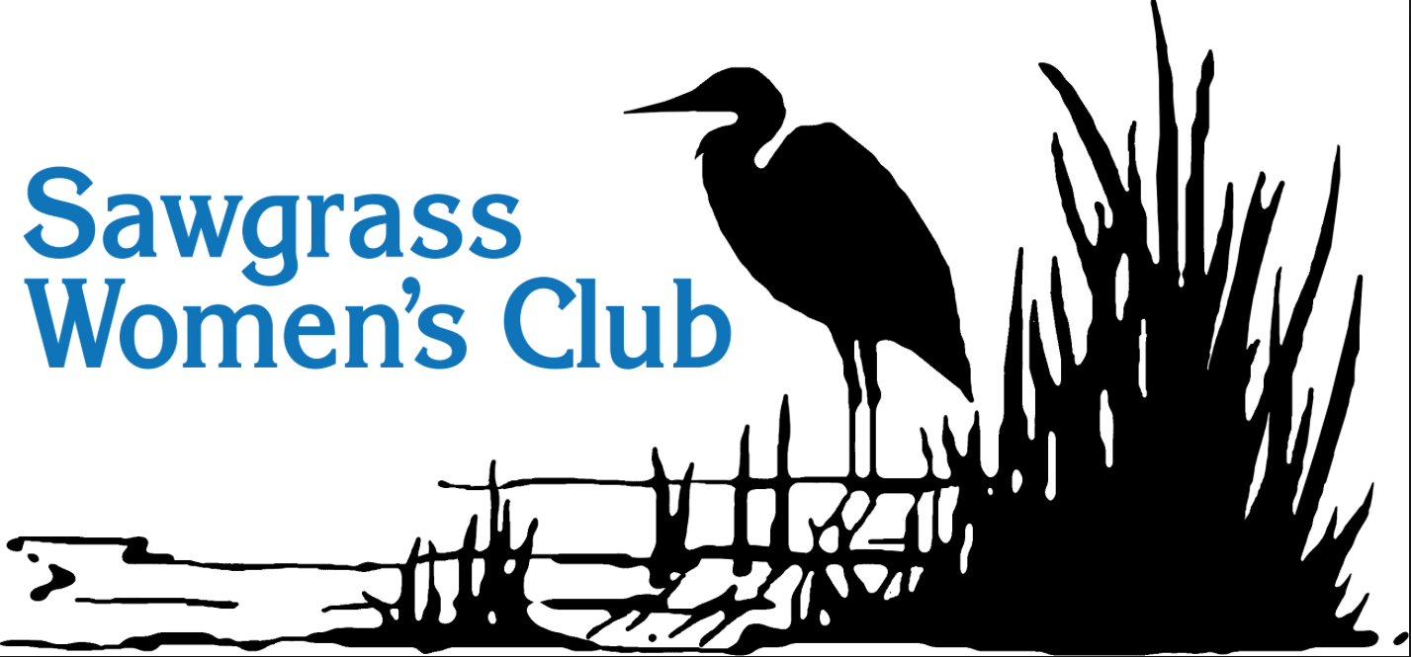
SAWGRASS WOMEN'S CLUB MEETING DATES
SEPTEMBER 2018 – MAY 2019
Monday, September 10, 2018 – Golf Clubhouse – 10:00 A.M.
Monday, October 8, 2018 – Golf Clubhouse – 10:00 A.M.
Monday, November 12, 2018 – Golf Clubhouse –10:00 A.M.
Tuesday, December 4, 2018 – Golf Clubhouse – 6:00 P.M.
HOLIDAY PARTY
Monday, December 10, 2018 – Golf Clubhouse – 10:00 A.M.
HOLIDAY PROGRAM & LUNCHEON
Monday, January 14, 2019 – Golf Clubhouse – 10:00 A.M.
Monday, February 11, 2019 – Golf Clubhouse – 10:00 A.M.
Monday, March 11, 2019 – Beach Club – 10:00 A.M.
Monday, April 1, 2019 – Beach Club – 11:00 A.M.
FASHION SHOW
Monday, May 13, 2019 – Beach Club – 10:00 A.M.
INSTALLATION OF OFFICERS

